**BookStore Using REACTJS**

*Project report (CA3) submitted in fulfilment of the requirements for the degree of*

# BACHELOR OF TECHNOLOGY

# in

**COMPUTER SCIENCE AND ENGINEERING**

By

## ADARSH SHIVAM

**(12115538)**

SUBJECT

## INT252:WEB APP DEVELOPMENT WITH REACTJS



## School of Computer Science and Engineering

Lovely Professional University

Phagwara, Punjab (India)

# TABLE OF CONTENTS

1. **INTRODUCTION .........................................................................................** 01
   1. **PROBLEM STATEMENT .................................................................**01
   2. **WHY USE REACTJS? .......................................................................**01
   3. **REACTJ ARCHITECTURE...............................................................**02
2. **TECHNOLOGIES USED.............................................................................** 07
   1. **JAVASCRIPT .....................................................................................**08
   2. **REACT ...............................................................................................** 09
   3. **TAILWINDCSS...................................................................................**10
3. **KEY FEATURES OF THE APP ..................................................................** 07
4. **MODULES ....................................................................................................** 09
5. **WEBSITE SNAPSHOTS..............................................................................** 14
6. **GITHUB LINK .............................................................................................** 17
7. **LIST OF REFERENCES..............................................................................** 18

i

# INTRODUCTION

**1.1 PROBLEM STATEMENT**

The aim of this project is to design and develop a comprehensive online bookstore website that caters to the diverse reading interests of users. The website will offer a wide range of books across various genres including stories, sports, music, and others. Additionally, the platform will provide users with the convenience of purchasing both paid and free books.

Key Objectives:

1. **Diverse Book Collection**: Create a platform that hosts an extensive collection of books spanning different genres such as stories, sports, music, and others to cater to the varied interests of users.
2. **User-Friendly Interface**: Design an intuitive and user-friendly interface that allows visitors to easily navigate through the website, search for specific books, and browse different categories.
3. **Purchase Options**: Implement a seamless purchasing system that enables users to buy both paid and free books with ease. Ensure secure payment gateways for transactions involving paid books.
4. **Free Book Availability**: Provide a selection of free books to users, allowing them to access quality reading material without any cost.
5. **Personalization**: Incorporate features that enable personalized recommendations based on users' reading preferences and browsing history, enhancing the overall user experience.
6. **Accessibility**: Ensure the website is accessible across various devices including desktops, laptops, tablets, and smartphones, allowing users to access the platform conveniently from anywhere.
7. **Reliable Search Functionality**: Develop a robust search functionality that enables users to find their desired books quickly by title, author, genre, or keywords.
8. **Content Management**: Implement a content management system (CMS) that allows easy addition, editing, and removal of books to keep the inventory up-to-date and relevant to users' interests.
9. **Feedback Mechanism**: Integrate a feedback mechanism where users can rate and review books, helping other users make informed decisions about their purchases.
10. **Security and Privacy**: Prioritize the security and privacy of users' personal information and payment details by implementing industry-standard security measures and compliance with relevant data protection regulations.

By addressing these objectives, the bookstore website will strive to provide users with a seamless and enjoyable online shopping experience while promoting a love for reading across various interests and preferences.Top of Form

**1.2 WHY USE REACTJS?**

Using ReactJS to build a bookstore website offers several advantages that align with the requirements and objectives of the project:

**1.** **\*\*Component-Based Architecture**:** ReactJS is built around the concept of reusable components, which makes it ideal for building complex user interfaces with ease. Each component can represent a specific part of the website, such as the book listing, search bar, or checkout process, facilitating modular development and easier maintenance.

**2. **Virtual DOM\*\***: React's virtual DOM efficiently updates only the necessary parts of the user interface when changes occur, resulting in faster rendering and improved performance. This is particularly beneficial for a dynamic website like a bookstore where content may frequently change based on user interactions.

**3. **Rich Ecosystem**:** React has a vast ecosystem of libraries and tools that complement its core functionality. This includes state management libraries like Redux for managing application state, React Router for handling navigation, and many UI component libraries for building visually appealing interfaces.

**4. **JSX**:** React uses JSX (JavaScript XML), a syntax extension that allows developers to write HTML-like code within JavaScript. This declarative approach makes it easier to visualize and understand the structure of the UI, leading to more maintainable code.

**5. **Server-Side Rendering (SSR)**:** React supports server-side rendering, which can improve the initial load time of the website and enhance search engine optimization (SEO) by delivering pre-rendered HTML to the client. This is advantageous for improving the website's performance and accessibility.

**6. **Community Support**:** React has a large and active community of developers who contribute to its development and provide support through forums, tutorials, and open-source projects. This community-driven approach ensures ongoing improvements, bug fixes, and access to a wealth of resources for developers.

**7. **Scalability**:** React is well-suited for building scalable applications that can handle a large number of users and concurrent interactions. Its component-based architecture and efficient rendering make it easier to scale the application as the bookstore website grows in terms of users and features.

**8. **Compatibility**:** React can be integrated with other JavaScript frameworks and libraries, allowing developers to leverage existing code or functionalities if needed. This flexibility enables seamless integration of additional features or services into the website as required.

Overall, **ReactJS** provides a robust and flexible framework for building a **modern**, **interactive**, and **scalable** bookstore website that meets the project's objectives effectively.

**1.3 REACTJS ARCHITECTURE**

The structure the architecture of your bookstore website using ReactJS, Tailwind CSS, React DOM, and React Hooks:

1. **Component-Based Architecture**:
   * Divide the user interface into reusable components based on their functionality. For example, you might have components for the book listing, search bar, navigation menu, book details, and checkout process.
   * Each component should encapsulate its own logic, styling, and behavior, making it easier to maintain and reuse throughout the application.
2. **Folder Structure**:
   * Arrange your project files into a structured folder hierarchy.
3. **React Router**:
   * Use React Router for handling navigation between different pages of the website. Define routes for each page component, such as the home page, book details page, and checkout page.
   * Implement route parameters to dynamically display content based on the selected book or category.
4. **Tailwind CSS Integration**:
   * Integrate Tailwind CSS into your project to streamline the styling process. Use Tailwind's utility classes to style components and layout elements.
   * Create custom utility classes or extend Tailwind's existing utility classes to maintain a consistent design across the website.
5. **React Hooks**:
   * Utilize React Hooks to manage component state, side effects, and other React features.
   * For example, use the useState hook to manage local component state, useEffect hook to fetch data from an API when the component mounts, and custom hooks for reusable logic such as form validation or data fetching.
6. **State Management**:
   * For simple state management, use React's built-in useState and useContext hooks.
   * For more complex state management requirements, consider integrating libraries like Redux or Recoil to manage global application state.
7. **API Integration**:
   * Use the useEffect hook to fetch data from a backend API when the component mounts or when certain dependencies change.
   * Create custom hooks to encapsulate API logic and reuse it across different components.
8. **Component Styling**:
   * Combine Tailwind CSS with inline styles or CSS modules for component-specific styling.
   * Leverage Tailwind's utility classes for responsive design and layout adjustments.

By following this architecture, you can build a scalable and maintainable bookstore website using ReactJS, Tailwind CSS, React DOM, and React Hooks, while effectively managing state, styling, and navigation within the application.

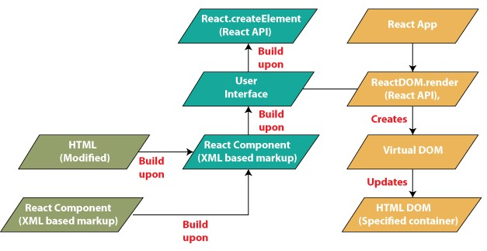

Figure 1:REACTJS architecture of the application

The Component-Based Architecture pattern in ReactJS is a modern approach to building user interfaces, especially for web applications. It breaks down the application into reusable and independent components, each with its specific responsibility and functionality. This architectural pattern promotes a clear separation of concerns and enhances the maintainability, scalability, and reusability of the codebase.

**Characteristics of ReactJS Components:**

• **Functional Components (View)**:

* Render UI elements and display data to the user.
* Receive and handle user input, such as clicks or form submissions.
* Typically consist of JSX templates, CSS styles, and other UI elements that define the visual representation of the component.
* Focus solely on the presentation and have no knowledge of the application's business logic or data processing.

• **Class Components (Controller)**:

* Manage the component's state and lifecycle methods.
* Handle user interactions and events, such as fetching data from APIs or updating the state based on user input.
* Act as the bridge between the View and any external data sources or services.
* Encapsulate the business logic and behavior specific to the component.

• **Stateless Components (Model)**:

* Receive data through props from parent components or containers.
* Define the structure and shape of the data.
* Purely functional and stateless, meaning they do not manage any internal state or lifecycle methods.
* Focus on rendering UI based on the provided data and have no knowledge of where the data comes from or how it's managed.

**Advantages of ReactJS Component-Based Architecture:**

* **Separation of Concerns**: React's component-based approach enforces a clear separation of concerns, allowing developers to focus on building individual components without worrying about the entire application's complexity. This leads to more maintainable and understandable code.
* **Code Reusability**: Components can be reused across different parts of the application or even in different projects, reducing redundancy and promoting consistency in design and functionality.
* **Scalability**: The modular nature of React components makes it easier to scale the application by adding new components or updating existing ones without affecting the overall application.
* **Parallel Development**: Different developers or teams can work on separate components simultaneously, speeding up the development process and improving efficiency.
* **Testing**: Each React component can be tested in isolation using tools like Jest and React Testing Library, making it easier to write unit tests and ensure the quality and reliability of the code.

By adopting the Component-Based Architecture pattern in ReactJS for "bookStore", the application benefits from a well-organized, modular, and maintainable codebase. This architectural approach ensures a smooth development process, improved code quality, and a better user experience for pet lovers using the platform.

The project introduces a ReactJS-based pet adoption and pet product marketplace application, named "bookStore," to address the challenges associated with book store, and community engagement. With a focus on usability, personalization, and fostering a book-loving community, the application aims to provide a comprehensive and enjoyable experience for book enthusiasts.

By leveraging ReactJS, Component-Based Architecture, and modern frontend development practices, the project aims to deliver a robust, scalable, and maintainable solution tailored to the diverse needs of book owners.

By harnessing the capabilities of ReactJS, Component-Based Architecture, and a usercentric approach, "bookStore " aims to establish itself as a leading platform in the bookstore industry. The project endeavors to create a community-centric .

**2. TECHNOLOGIES USED**

**2.1 REACT**

ReactJS is a widely-adopted JavaScript library primarily used for building user interfaces, particularly for single-page applications. It offers several key features and characteristics that make it a popular choice for modern web development:

* **Declarative UI**: React uses a declarative programming paradigm, allowing developers to describe the desired UI state, and React takes care of updating the DOM to match that state efficiently.
* **Component-Based Architecture**: React promotes the development of reusable and composable components, enabling developers to build complex UIs from isolated pieces of code. This approach enhances code reusability and maintainability. • **Virtual DOM**: React utilizes a virtual DOM to optimize rendering performance. Instead of updating the entire DOM when changes occur, React updates a virtual representation and then efficiently updates only the changed parts in the actual DOM.
* **Cross-Platform Compatibility**: React can be used to build applications for various platforms, including web, mobile, and even desktop, thanks to frameworks like React Native and Electron.
* **Extensive Ecosystem**: React has a rich ecosystem with a vast collection of libraries, tools, and community-contributed components, enhancing its capabilities and speeding up development.
* **State Management**: React provides various state management solutions, such as Context API and third-party libraries like Redux, making it easier to manage and share state across components.
* **Integration with Backend Services**: React can seamlessly integrate with various backend services and databases, making it suitable for building full-stack applications. In your project, React can interact with backend APIs to fetch or update data stored in databases like MySQL.

By leveraging these features and characteristics, ReactJS offers developers a powerful and flexible toolset for building interactive and dynamic user interfaces. Its focus on component-based development, performance optimization, and extensive ecosystem makes it an ideal choice for modern web applications that require scalability, maintainability, and a rich user experience.

**2.2 JAVASCRIPT**

JavaScript is a versatile and widely-used programming language primarily known for its capability to add interactivity to web pages. JavaScript offers a range of features and functionalities that facilitate the creation of dynamic and responsive web applications:

* **Event-Driven Programming**: JavaScript employs an event-driven programming paradigm, allowing developers to create interactive web pages by responding to user actions like clicks, mouse movements, and keyboard inputs.
* **DOM Manipulation**: JavaScript provides APIs to manipulate the Document Object Model (DOM) of web pages, enabling developers to dynamically change content, styles, and attributes based on user interactions or application state changes.
* **Asynchronous Programming**: JavaScript supports asynchronous programming through callbacks, promises, and async/await, enabling the execution of non-blocking code and improving application performance by handling time-consuming operations efficiently.
* **Functional Programming**: JavaScript supports functional programming concepts like higher-order functions, closures, and immutability, enabling developers to write cleaner, more maintainable, and modular code.
* **Cross-Platform Compatibility**: JavaScript can run in various environments, not just browsers. With the advent of Node.js, JavaScript can now be used to build serverside applications, desktop applications, and even mobile applications using frameworks like React Native.
* **Extensive Ecosystem**: JavaScript has a vast ecosystem with a multitude of libraries, frameworks, and tools, such as React, Angular, Vue.js, and jQuery, that extend its capabilities and simplify web development tasks.
* **Modularity and Reusability**: With the introduction of ES6 (ECMAScript 2015) and later versions, JavaScript supports features like modules and classes, promoting code modularity, reusability, and maintainability.

By leveraging these features and characteristics, JavaScript offers developers a flexible and powerful language for building modern web applications. Its ability to handle both client-side and server-side development, combined with its rich ecosystem and community support, makes it an indispensable tool for web developers aiming to create interactive, scalable, and efficient web solutions.

**2.3 TAILWIND CSS**

Tailwind CSS is a utility-first CSS framework that provides a set of pre-designed utility classes to style your HTML elements. It differs from traditional CSS frameworks like Bootstrap or Foundation by focusing on low-level utility classes rather than pre-designed components. Here's an overview of key features and concepts of Tailwind CSS:

**1. **Utility-First Approach**:**

- Tailwind CSS follows a utility-first approach, where styles are applied directly to HTML elements using utility classes.

- Instead of writing custom CSS rules, you can use predefined utility classes to apply styles such as margins, padding, colors, and typography directly in your HTML markup.

**2. **Modular and Composable**:**

- Tailwind CSS provides a wide range of utility classes that can be combined and composed to create custom designs.

- Utilities are designed to be modular and composable, allowing you to mix and match classes to achieve the desired styling without writing custom CSS.

**3. **Responsive Design**:**

- Tailwind CSS includes responsive utility classes that allow you to apply different styles based on the screen size.

- You can use breakpoints like `sm`, `md`, `lg`, and `xl` to define styles for various screen sizes, enabling you to create responsive layouts easily.

**4. **Customization**:**

- Tailwind CSS is highly customizable, allowing you to configure and extend its default styles to match your project's design requirements.

- You can customize colors, spacing, typography, breakpoints, and more using Tailwind's configuration file.

**5. **Optimized for Performance**:**

- Tailwind CSS generates minimal CSS output by only including the styles that are used in your project, resulting in smaller file sizes and faster load times.

- The utility-first approach reduces redundancy in your CSS code and eliminates the need for additional CSS preprocessing or compilation steps.

**6. **Developer Experience**:**

- Tailwind CSS enhances developer productivity by providing a consistent and predictable set of utility classes.

- It offers helpful features such as IntelliSense support in code editors, which makes it easy to discover and apply utility classes while coding.

**7. **Community and Ecosystem**:**

- Tailwind CSS has a vibrant community of developers who contribute plugins, extensions, and resources to extend its functionality.

- There are various third-party tools and integrations available for Tailwind CSS, including plugins for popular JavaScript frameworks like React, Vue.js, and Angular.

Overall, Tailwind CSS offers a modern and efficient approach to styling web applications, allowing developers to create responsive and customizable designs quickly without sacrificing performance or scalability. Its utility-first philosophy and extensive feature set make it a popular choice for building modern UIs.

# 3.KEY FEATURES OF THE APP

**1. **User Authentication**:** Allow users to create accounts, sign in, and manage their profiles. This feature enables personalized experiences, such as saving favorite books, viewing order history, and managing payment methods.

**2. **Book Categories and Search**:** Organize books into categories such as stories, sports, music, and others to help users discover new titles. Implement a robust search functionality that enables users to find books by title, author, genre, or keywords.

**3. **Book Listings**:** Display book listings with detailed information including title, author, description, cover image, price, and availability. Provide options for sorting and filtering the book catalog based on criteria such as popularity, release date, and price.

**4. **Book Details Page\*\***: Create dedicated pages for each book with additional details such as reviews, ratings, excerpts, and related books. Include social sharing buttons to encourage users to share their favorite books with others.

**5. **Shopping Cart and Checkout**:** Allow users to add books to a shopping cart and proceed to checkout to complete their purchases. Implement a secure payment gateway for processing transactions and support multiple payment methods such as credit/debit cards, PayPal, and others.

**6. **Wishlist and Save for Later**:** Enable users to save books to a wishlist for future purchase or to save items for later consideration. This feature helps users keep track of books they are interested in and encourages return visits to the bookstore.

**7. **Free Books Section**:** Highlight a selection of free books that users can download or read online at no cost. This feature attracts users to the platform and provides them with access to quality reading material without any financial commitment.

**8. **Recommendation Engine**:** Implement a recommendation engine that suggests books based on users' browsing history, purchase history, and preferences. Personalized recommendations enhance the user experience and increase engagement with the platform.

**9. **User Reviews and Ratings**:** Allow users to rate and review books they have read, providing valuable feedback to other users and helping them make informed decisions about their purchases.

**10. **Responsive Design**:** Ensure the application is fully responsive and accessible across various devices and screen sizes, including desktops, laptops, tablets, and smartphones. A responsive design provides a seamless user experience regardless of the device being used.

**11. **Admin Panel**:** Provide an admin panel for managing book inventory, user accounts, orders, and other aspects of the application. Admins should have the ability to add, edit, and delete books, as well as view analytics and reports.

By incorporating these key features into your bookstore application, you can create a **comprehensive** and **user-friendly** platform that caters to the **diverse reading** interests of users while providing a seamless shopping experience.

# MODULES

In the context of a bookstore application, modules represent distinct functional units or components that encapsulate related features and functionality. Here are some suggested modules for a bookstore application:

**1. **Authentication Module**:**

- Handles user registration, login, logout, and profile management.

- Ensures secure access to user-specific features such as wishlist management and order history.

**2. **Book Catalog Module**:**

- Manages the display and organization of books within the bookstore.

- Includes features for browsing, searching, sorting, and filtering books based on various criteria such as genre, author, title, and price.

- Provides detailed information about each book, including descriptions, cover images, ratings, and reviews.

**3. **Shopping Cart Module**:**

- Allows users to add books to their shopping cart for purchase.

- Manages the contents of the shopping cart, including quantity adjustments, removal of items, and subtotal calculation.

- Integrates with the checkout module for order processing.

**4. **Checkout Module**:**

- Facilitates the completion of purchases and payment processing.

- Collects shipping and billing information from users.

- Integrates with payment gateways to securely process transactions using various payment methods.

**5. **Wishlist Module**:**

- Enables users to save books for future consideration or purchase.

- Allows users to add, remove, and manage books in their wishlist.

- Provides notifications or reminders for books in the wishlist.

**6. **Recommendation Module**:**

- Utilizes algorithms to generate personalized book recommendations for users based on their browsing history, purchase history, and preferences.

- Enhances user engagement and encourages exploration of new books.

**7. **Admin Module**:**

- Provides administrative functionality for managing the bookstore application.

- Allows administrators to add, edit, and delete books from the catalog.

- Manages user accounts, orders, payments, and other system settings.

- Generates reports and analytics to track sales, inventory, and user activity.

8. **User Reviews and Ratings Module**:

- Allows users to rate and review books they have read.

- Displays aggregate ratings and reviews for each book.

- Provides feedback mechanisms to help users make informed decisions about their purchases.

**9. **Free Books Module**:**

- Highlights a selection of free books available for download or online reading.

- Provides a separate section or category for users to discover and access free content.

**10. **Responsive Design Module**:**

- Ensures the application is accessible and functional across various devices and screen sizes.

- Adapts the user interface and layout to provide an optimal viewing and interaction experience on desktops, laptops, tablets, and smartphones.

These modules can serve as the building blocks for developing a comprehensive and feature-rich bookstore application that meets the needs of users and administrators alike. Each module encapsulates specific functionality, making the application easier to develop, maintain, and scale.

**5.WEBSITE SNAPSHOTS**

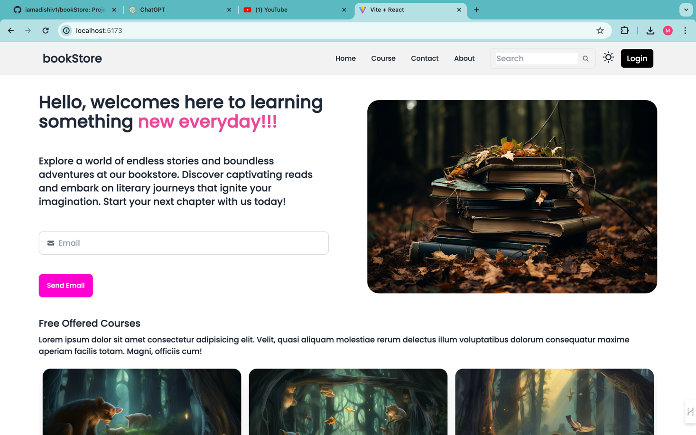

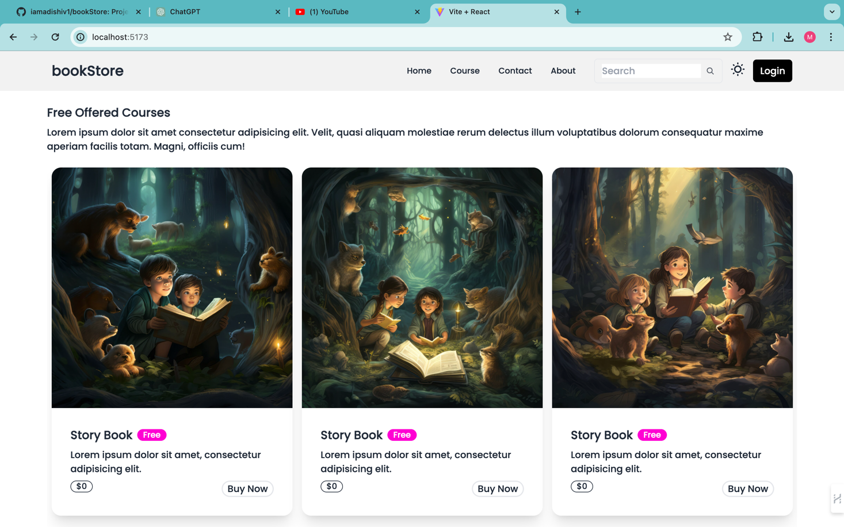

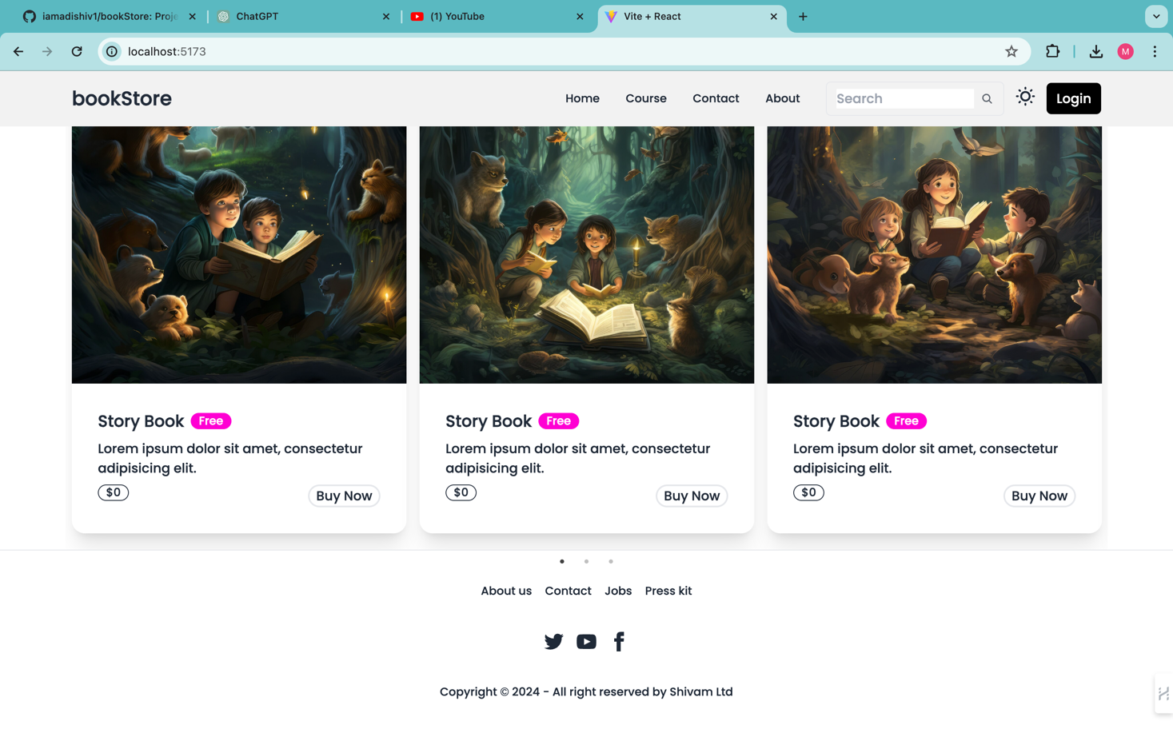

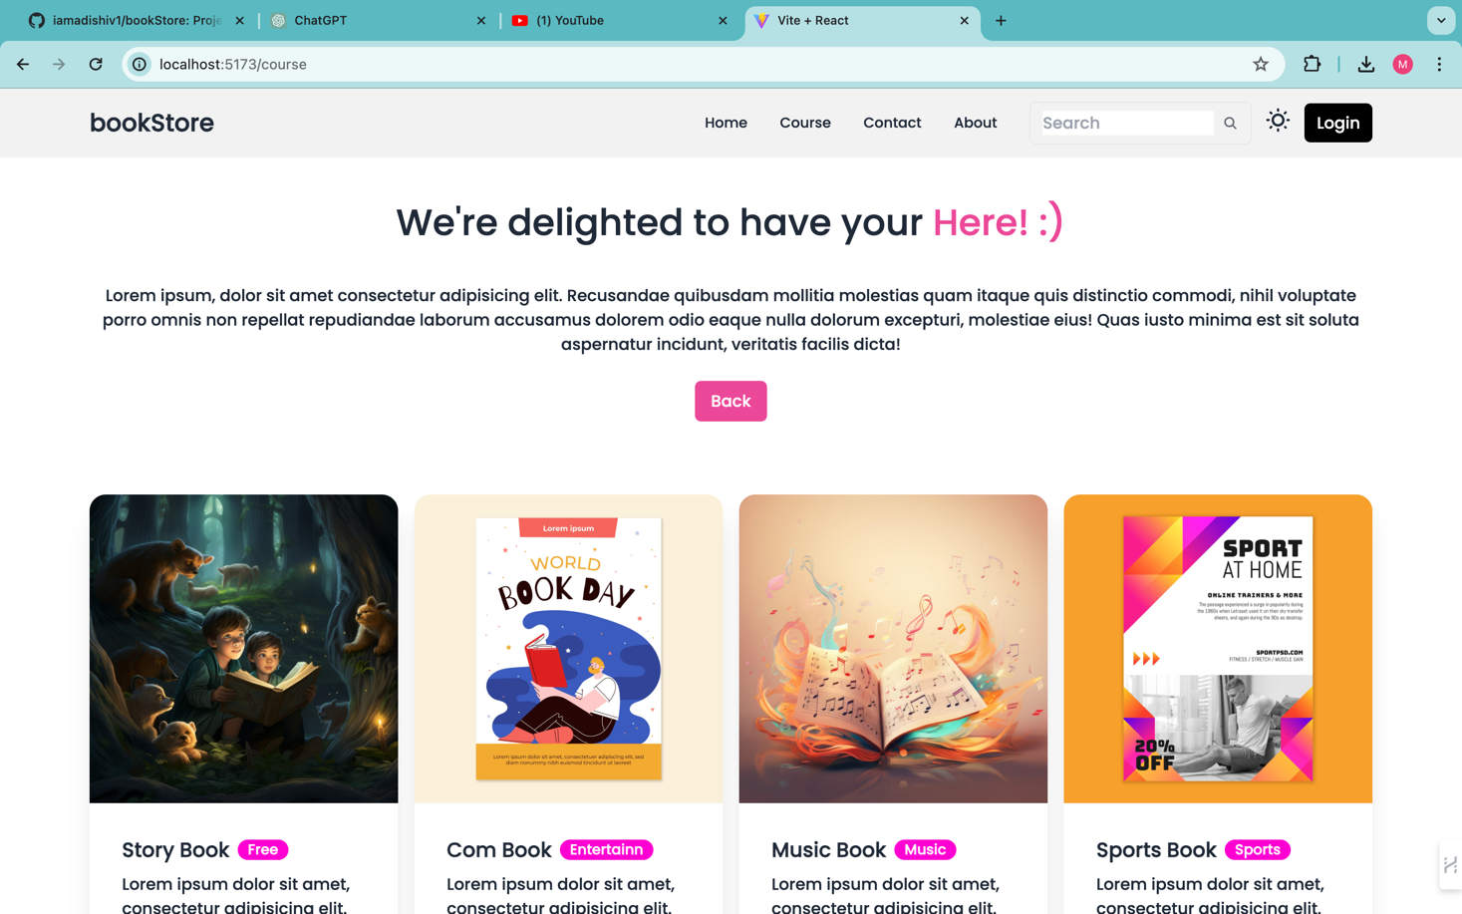

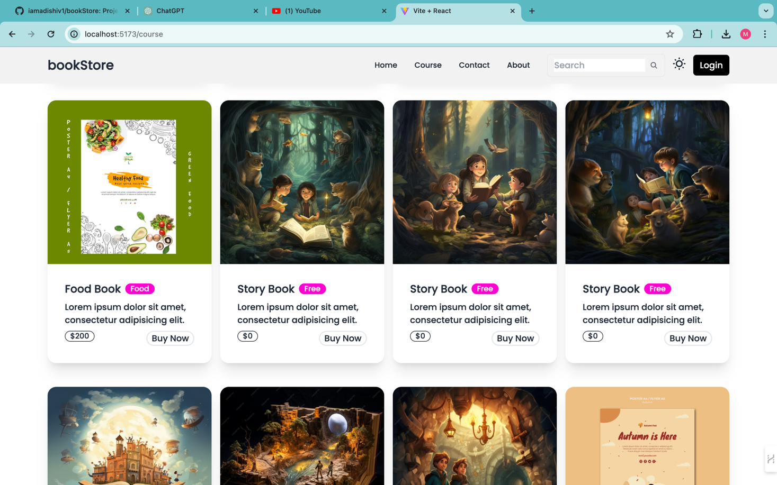

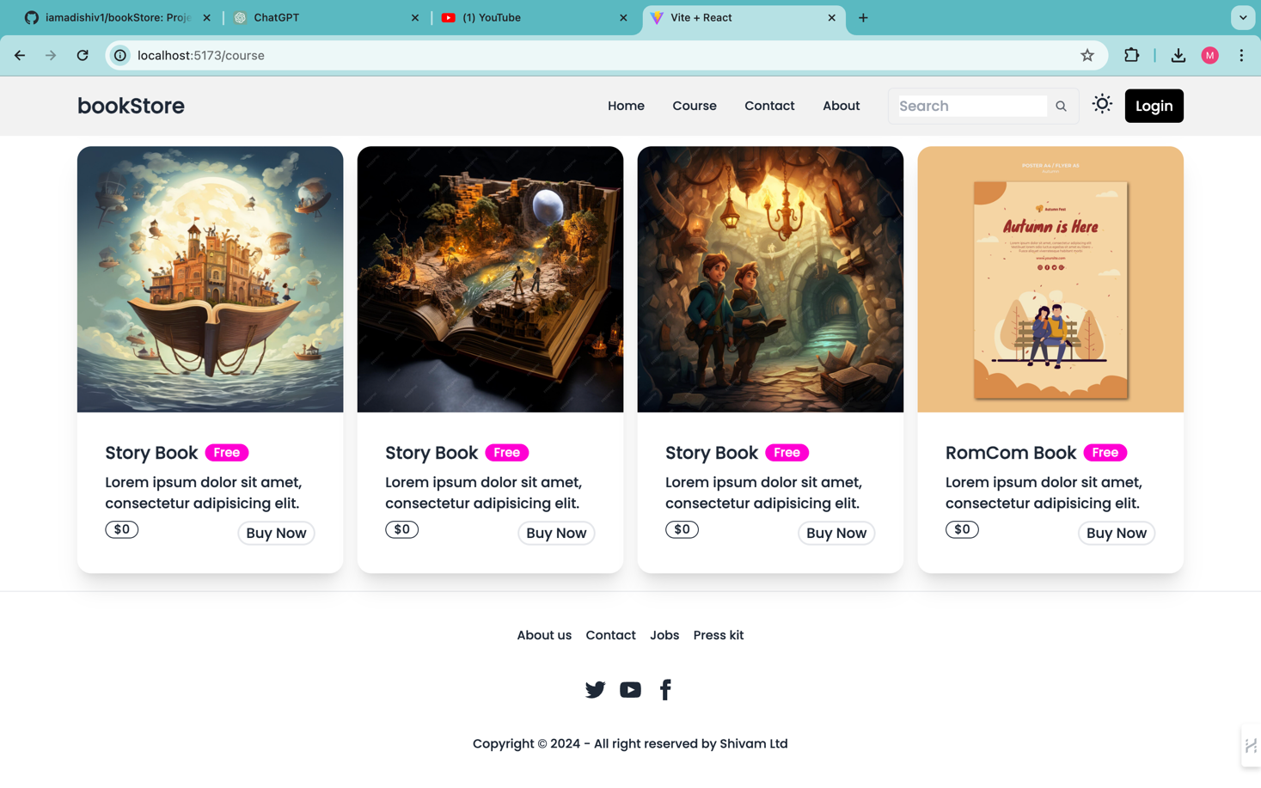

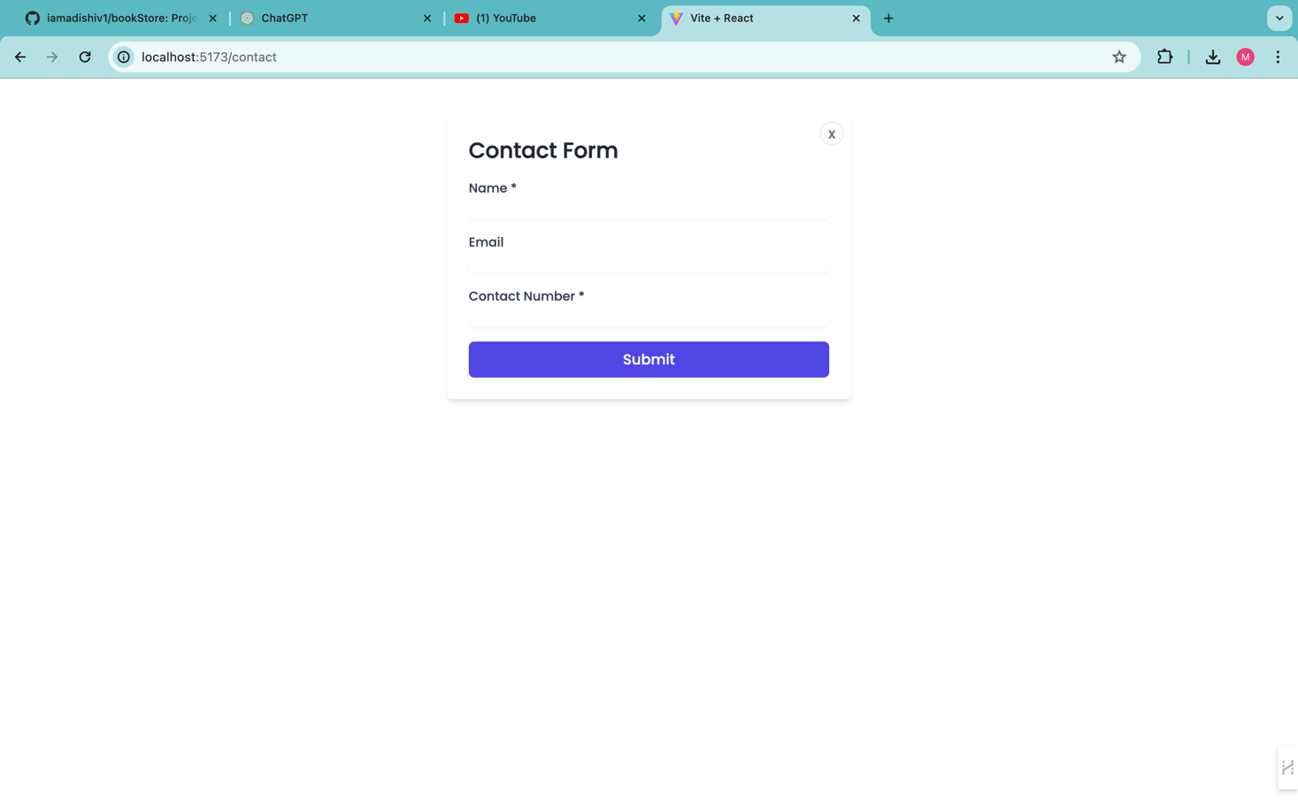

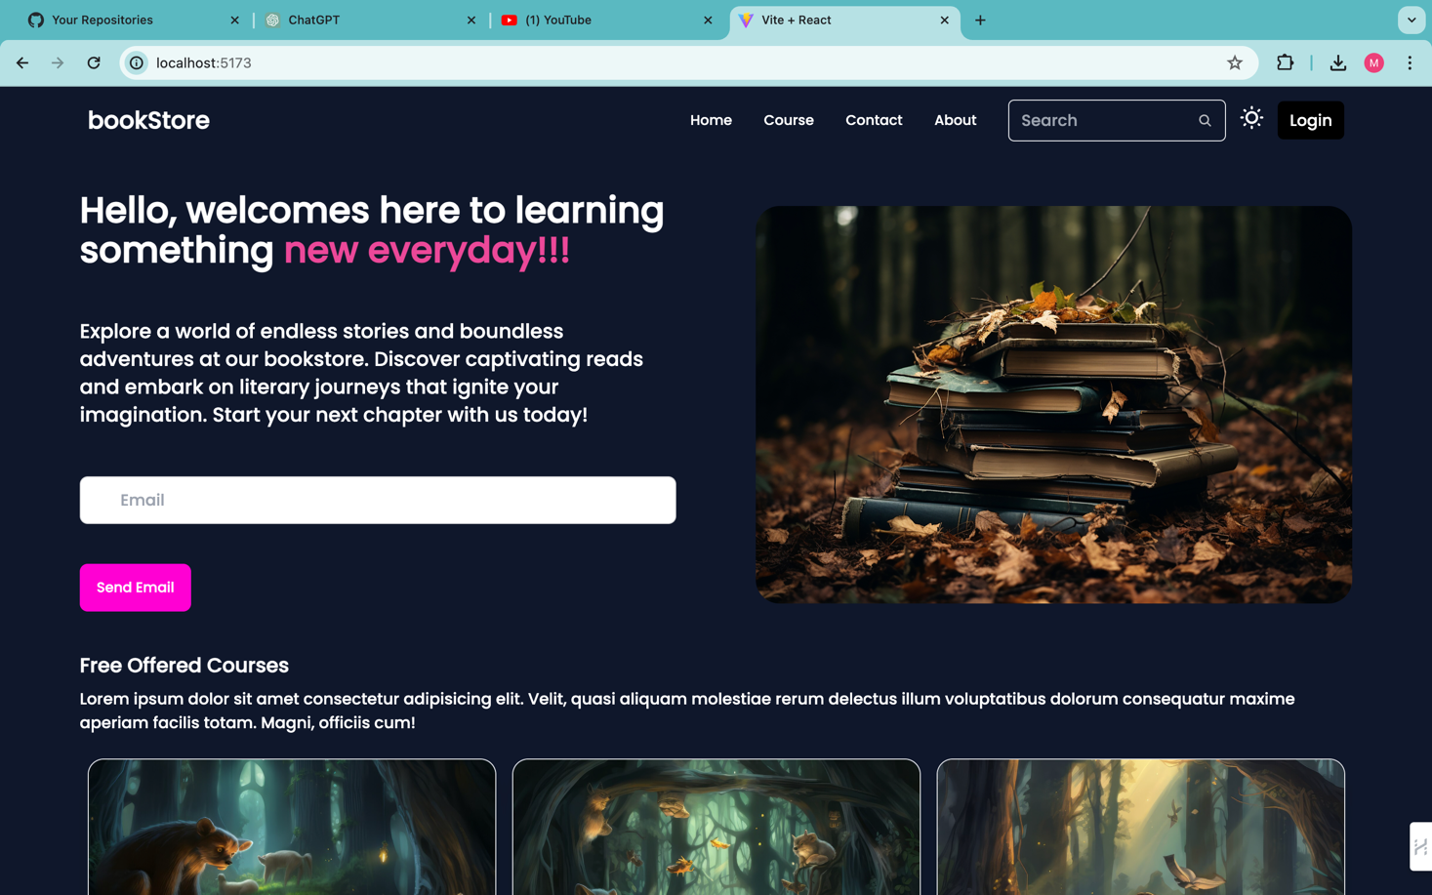

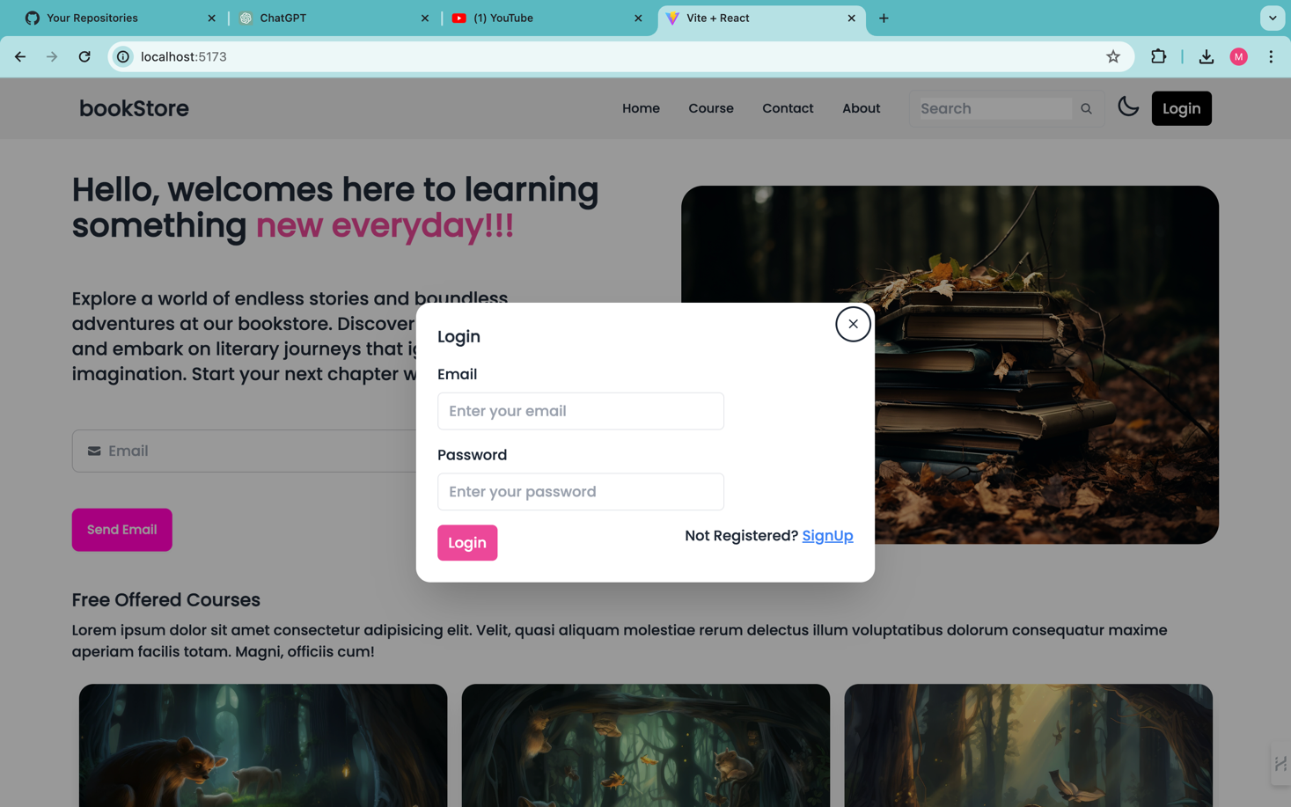

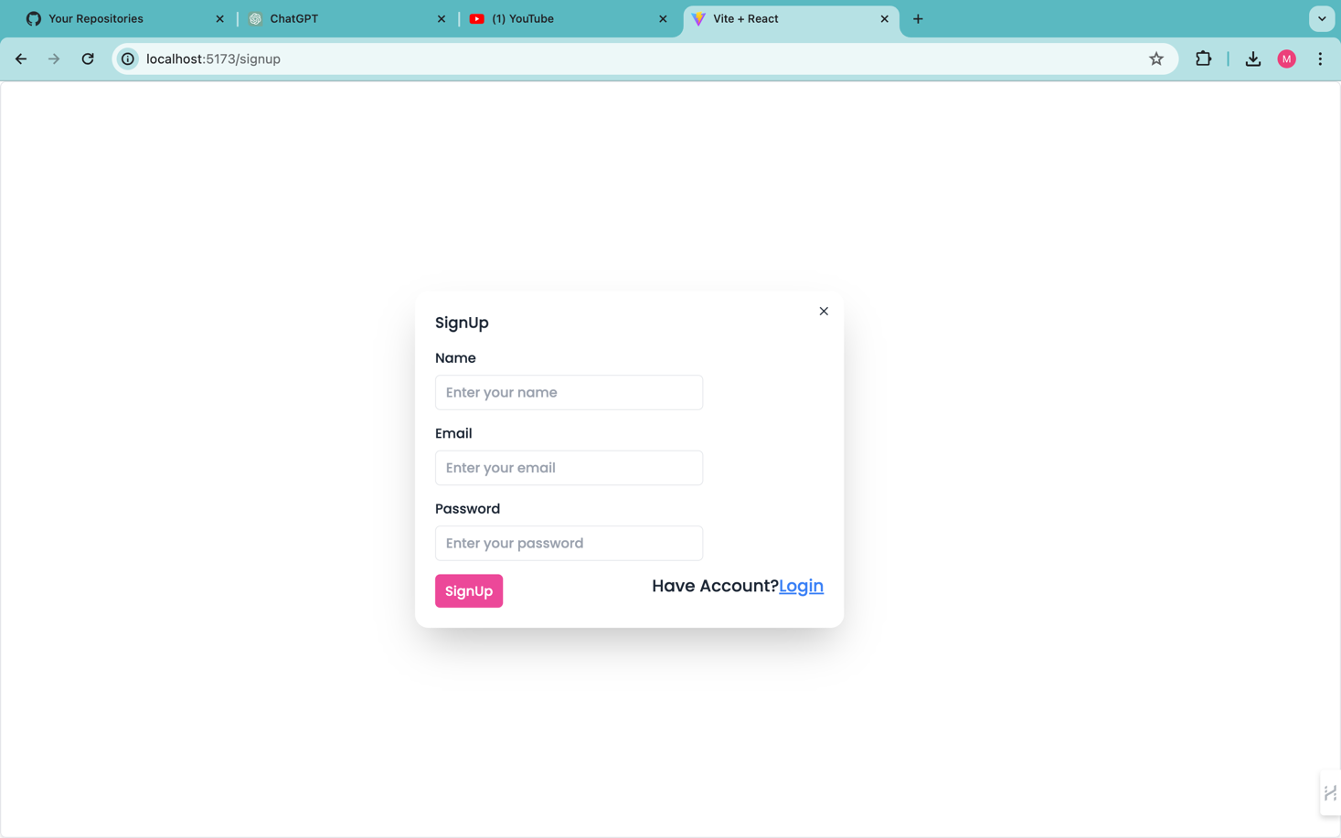

# 6.GITHUB LINK

# <https://github.com/iamadishiv1/bookStore>

# 7.LIST OF REFERENCES

* <https://www.w3schools.com/html/>
* <https://www.javatpoint.com/reactjs-tutorial>
* <https://www.all4pets.in/>
* <https://www.w3schools.com/REACT/DEFAULT.ASP>
* <https://react-tutorial.app/>
* <https://www.geeksforgeeks.org/react-tutorial/>

**THANK YOU;)**